1. Create a GitHub account.

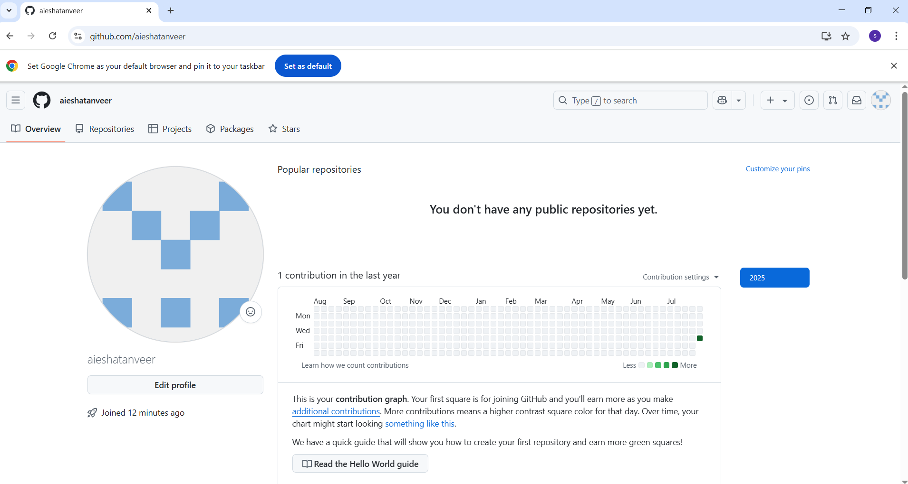

1. Setup MFA to GitHub account using mobile app.

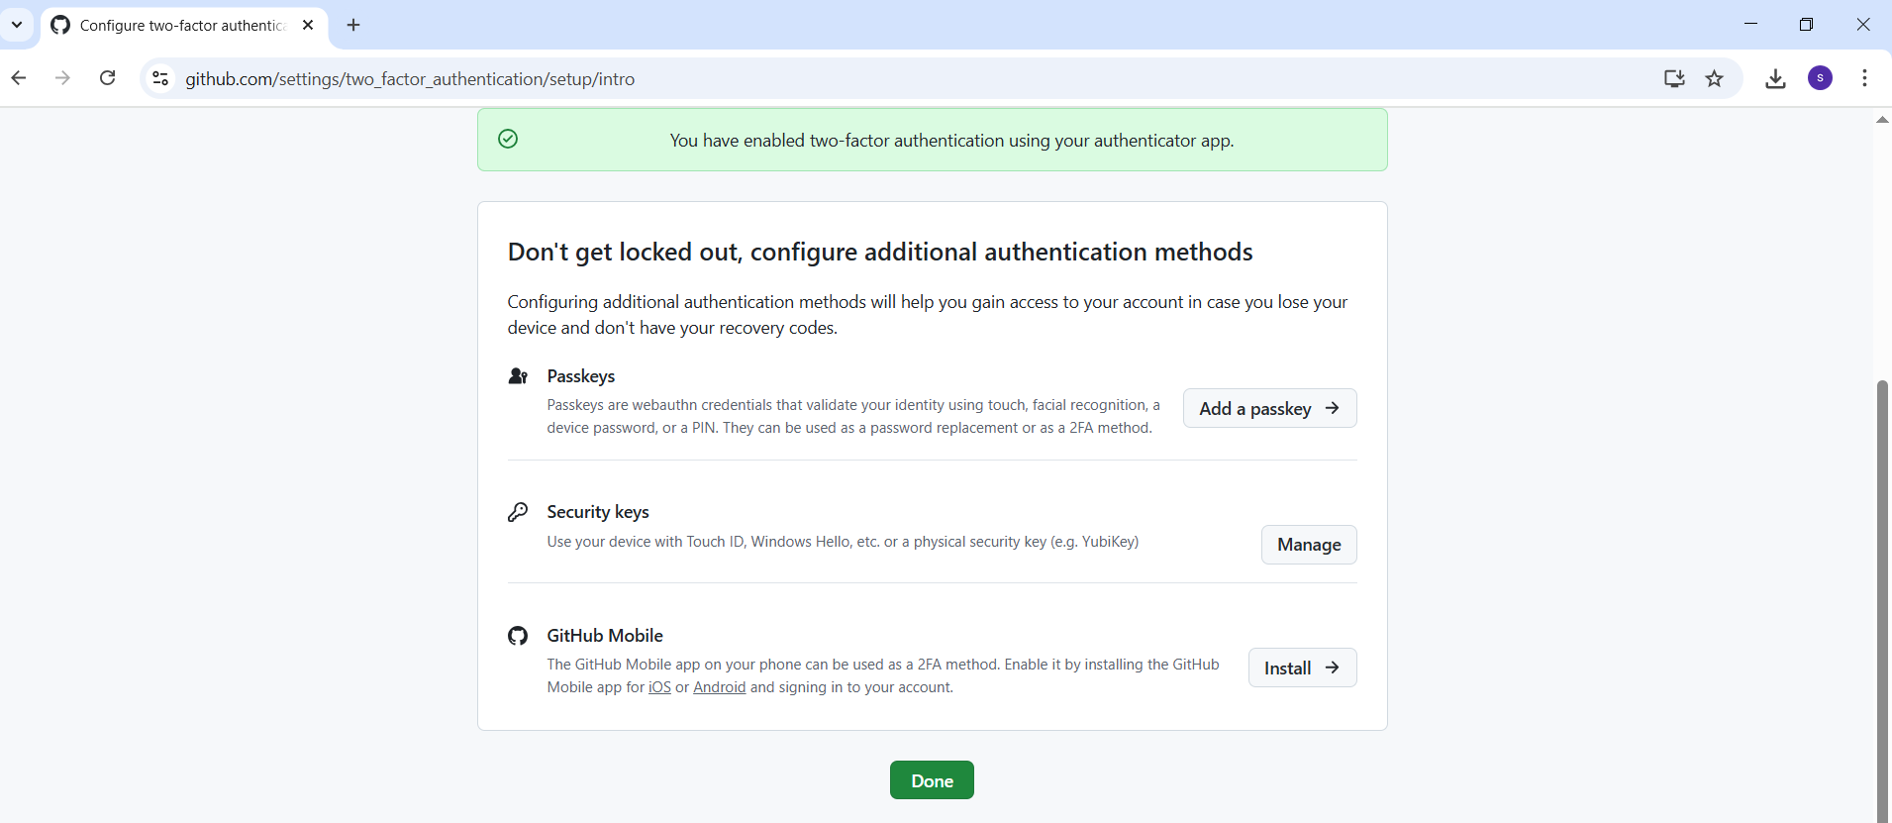

1. **Execute all the commands shown in the video.**
2. To check the git version.

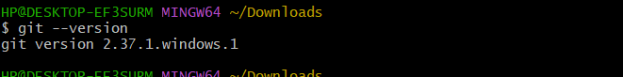

1. Initialize git repository.



1. Configuration details of files.

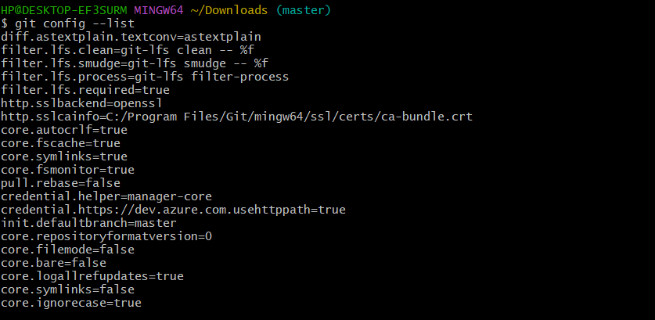

1. Configure user name.

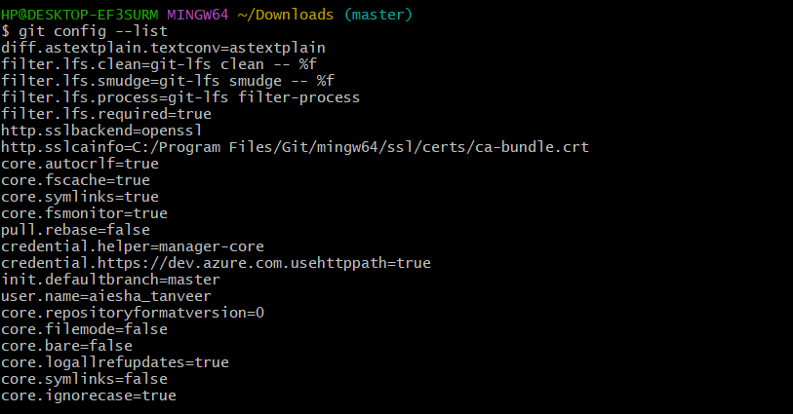

1. Configure email.

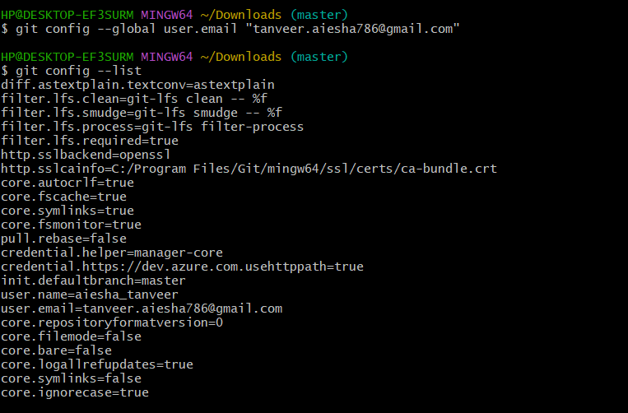

1. Create a file and move untracking files to tracking.

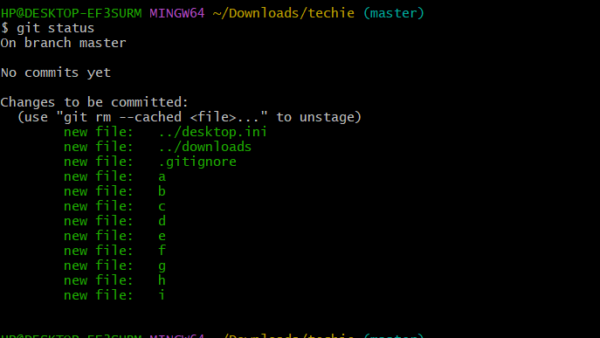

1. Commit the files.

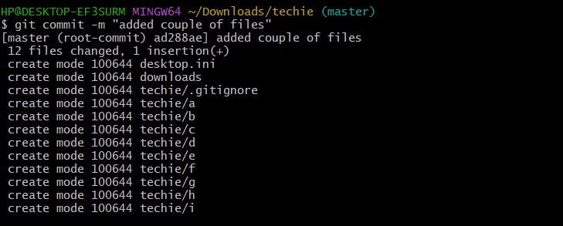

1. Log command.

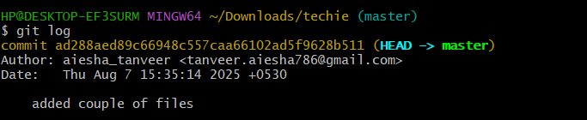

1. Add address.

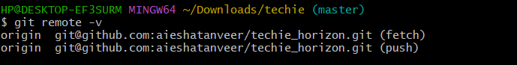

1. Generate public/private rsa key pair.

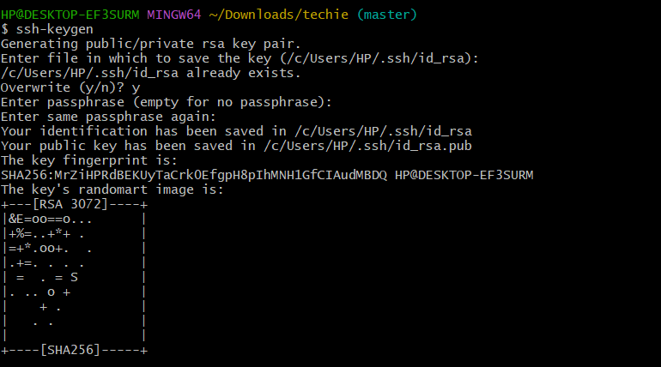

1. Using git push -u origin master command.

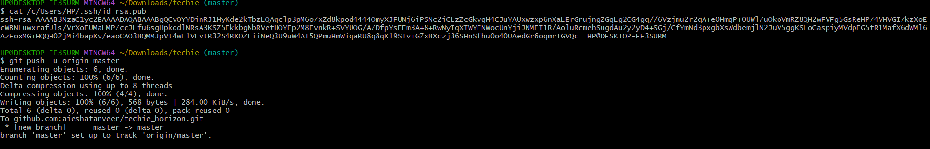

1. Cloning command.

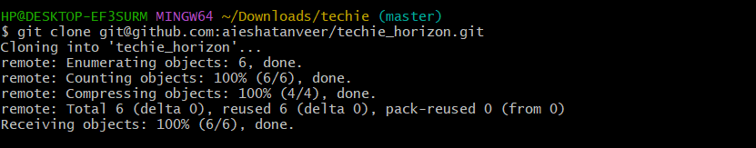

1. Create a file on main branch and pull it to local machine.

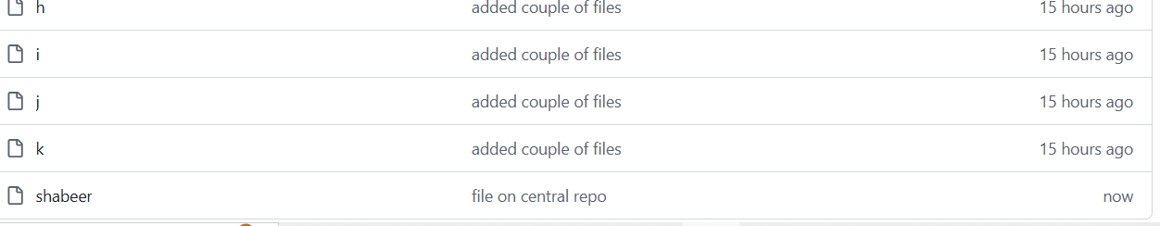

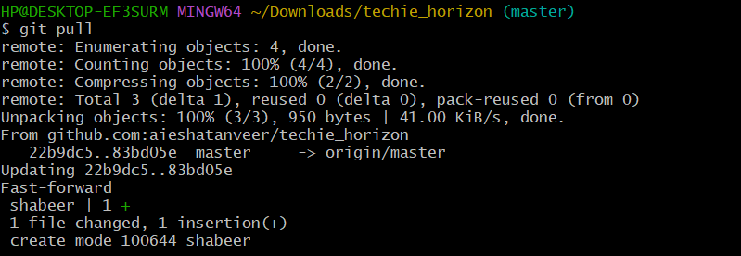

1. Get back the deleted files.

